GoFFA Northwest Tour June 26 – July 4, 2022
Oklahoma, Nebraska, South Dakota, Wyoming, Montana
Professional Development Opportunity

The Munford FFA Chapter has organized a GoFFA Program in which we will be "Putting Culture in Agriculture". We want to increase the knowledge base of our teachers and students to what agriculture has to offer here in the United States. We will be taking a charter bus traveling to:
Drummond Land & Cattle - In a 2013 list of America’s largest landowners, the Drummonds ranked 17th with 433,000 acres. The ranch got its start in 1910, and today, brothers Tim and Ladd run 6,500 cow-calf pairs along with 12,000 stockers between two Oklahoma facilities. Drummond horses are bred to perform on the ranch and the arena, like their 2004 AQHA World Champion colt, Lizzy Gotta Player. The Drummond Ranch was inducted into the Oklahoma Quarter Horse Association Hall of Fame in 2013.
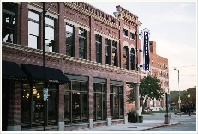
The Mercantile – The Pioneer Woman Mercantile is a destination restaurant, bakery and store in Pawhuska, Oklahoma! Ree and Ladd Drummond spent years renovating the hundred-year-old Osage Mercantile building on Main Street so that they could welcome visitors from near and far and give them a slice of small town hospitality.
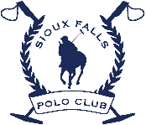
Sioux Falls Polo Club - The polo season in Sioux Falls runs from about May to September. They usually host 2 to 3 tournaments per season in June, July and August, sometimes September. They will have practices open to the public at our tournament field on Saturdays in season from May-September.
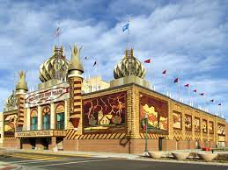
World’s Only Corn Palace – The original Mitchell Corn Palace (known as "The Corn Belt Exposition") was built in 1892 to showcase the rich soil of South Dakota and encourage people to settle in the area. It was a wooden castle structure on Mitchell's Main Street, constructed on land donated by Louis Beckwith, a member of the First Corn Palace Committee. The building is decorated with crop art; the murals and designs covering the building are made from corn and other grains, and a new design is constructed each year. The Corn Palace is a popular tourist destination, visited by up to 500,000 people each year.
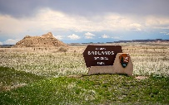
Badlands National Park - Badlands National Park is in South Dakota. Its dramatic landscapes span layered rock formations, steep canyons and towering spires. Bison, bighorn sheep and prairie dogs inhabit its sprawling grasslands. The Badlands Loop Road (Highway 240) winds past scenic lookouts.
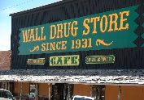
Wall Drug Store - Wall Drug has a rich history in the state of South Dakota. Nestled in the city of Wall in the western part of the state, Wall Drug has grown from its humble beginnings in 1931 to a thriving oasis. Wall Drug offers dining, activities, gifts and souvenirs, visitor information and, of course, free ice water. Many road-worn travelers stop at Wall Drug and leave awake and refreshed, just like they did more than 80 years ago.
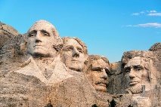
Mount Rushmore National Memorial - Majestic figures of George Washington, Thomas Jefferson, Theodore Roosevelt and Abraham Lincoln, surrounded by the beauty of the Black Hills of South Dakota, tell the story of the birth, growth, development and preservation of this country. From the history of the first inhabitants to the diversity of America today, Mount Rushmore brings visitors face to face with the rich heritage we all share.
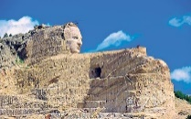
Crazy Horse Memorial- Crazy Horse is the world's largest mountain carving located in the Black Hills of South Dakota. It is considered The Eighth Wonder of the World in progress. Crazy Horse Memorial® is located in the heart of the beautiful Black Hills. The elevation on the Mountain is 6,532 feet above sea level and ranks 27th highest mountain in South Dakota. It is made of pegmatite granite and was chosen by Sculptor Korczak Ziolkowski & Lakota Chief Henry Standing Bear for the Crazy Horse Memorial.
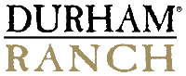
Durham Bison Ranch- In the 1930’s Armando Flocchini Sr., our grandfather, purchased the Durham Meat Company in San Francisco where he worked as a butcher. In 1965 he purchased a 55,000 acre bison ranch near Wright, Wyoming and renamed it Durham Ranch. Three generations later, this same ranch is operated by the Flocchini family and remains one the largest bison operations in North America.
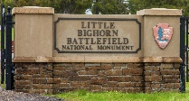
Little Big Horn National Battlefield- This area memorializes the US Army's 7th Cavalry and the Lakotas and Cheyennes in one of the Indian's last armed efforts to preserve their way of life. Here on June 25 and 26 of 1876, 263 soldiers, including Lt. Col. George A. Custer and attached personnel of the US Army, died fighting several thousand Lakota and Cheyenne warriors.
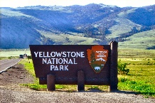
Yellowstone National Park - is an American national park located in the western United States, largely in the northwest corner of Wyoming and extending into Montana and Idaho. It was established by the U.S. Congress and signed into law by President Ulysses S. Grant on March 1, 1872.^{[6][7][8]} Yellowstone was the first national park in the U.S. and is also widely held to be the first national park in the world.^{[9]} The park is known for its wildlife and its many geothermal features, especially Old Faithful geyser, one of its most popular.
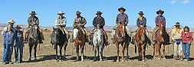
Rock Springs Wild Horse Holding Facility – Rock Springs, Wyoming
Horses are available for adoption by appointment year-round by first come/first serve.
This is the only federal short-term holding and preparation facility in Wyoming. The facility houses approximately 700 wild horses, primarily gathered from Wyoming herd management areas (HMA). The facility also serves as a rest stop location for wild horses being transported eastbound from western states.
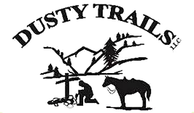
Dusty Trails - Tanking all starts with a stock tank, a river, and a group of people that want to float down the river… in a stock tank. Tanks are capable of holding 3 to 8 people and have benches with the added bonus of having room for a cooler. Tanking is a perfect way to spend a relaxing day on the water. You are able to float in shallow water, and roll off of obstruction such as downed trees. You don’t have to paddle or pole too much, except at times to push off of sandbars, stumps or weedy banks. All and all, tanking is an awesome dry water adventure that anyone from the age of 4 to 94 can take part in.
GoFFA Informational Meeting November 15, 2021 at 6:00 p.m.
(Also available on Zoom Conferencing)
Please feel free to look over the itinerary on the Munford FFA Chapter Website at http://munfordffa.ffanow.org if you have any questions please feel free to call me. This will be the ninth trip we have organized for group travel, and I certainly want it to be a successful professional development opportunity.

Cost of the Educational Opportunity…Is determined by the number of people that enroll.
Enrollment fee is $400 per person. Enrollment period ends December 15, 2021.
Enrollment fees are not on top of the cost of the trip; it is included in the overall cost.
Final Payment is due by June 15, 2022.

(30 Participant’s) Student Package - $1780 per student in a four person room Adult Package - $2110 per teacher/adult in a two person room
(50 Participant’s) Student Package - $1480 per student in a four person room Adult Package - $1810 per teacher/adult in a two person room
Includes bus transportation, hotels, tickets to all events & tours, breakfast and one other meal per day.
Please make checks payable to: Munford FFA Alumni
1080 McLaughlin Drive
Munford, TN 38058

Payment Plans: Student’s enrollment fees as well as monthly payments can be made online using a debit or credit card at http://munfordffa.ffanow.org. Once the enrollment period ends we will determine package cost based on the number enrolled. The prices listed are examples and the maximum you should expect to pay for the trip. For example if 40 people enroll the fee would be less than the marked 30 people price. Any questions regarding payment options can be directed to Mrs. Ann Johnson at 901-482-5951 or Mrs. Vicki Schulz at 901-232-8504
Example Plans for 30 people:
Students: Adults:
Enrollment Fee: $400 Enrollment Fee: $400
Monthly Payments: $230/month Monthly Payments: $285/month

Trip Cancellation Policy: In the event we do not have 30 participants enroll in the trip, all money will be completely refunded to those enrolled.

Individual Cancellation Policy: Individuals that withdraw from the trip will NOT receive a full refund. Once the trip makes (having 30 participants enrolled), the bus will be secured and that money is already spent. Therefore; $600 is non-refundable.

GoFFA Informational Meeting November 15, 2021 at 6:00 p.m.

